**Requirement Analysis Phase**

| Date | 20 Feb 2025 |
| --- | --- |
| Team ID | LTVIP2026TMIDS86637 |
| Project Name | hematovision: advanced blood cell classification using transfer learning |
| Maximum Marks | 4 Marks |

# **2. Requirement Analysis Phase**

## **2.1 Introduction**

The Requirement Analysis Phase focuses on identifying and documenting the functional, non-functional, technical, and user requirements of the proposed system. This phase ensures a clear understanding of what the system should do and how it should perform before moving into the design and development stages.

The requirements are gathered based on stakeholder needs, problem analysis, and feasibility considerations.

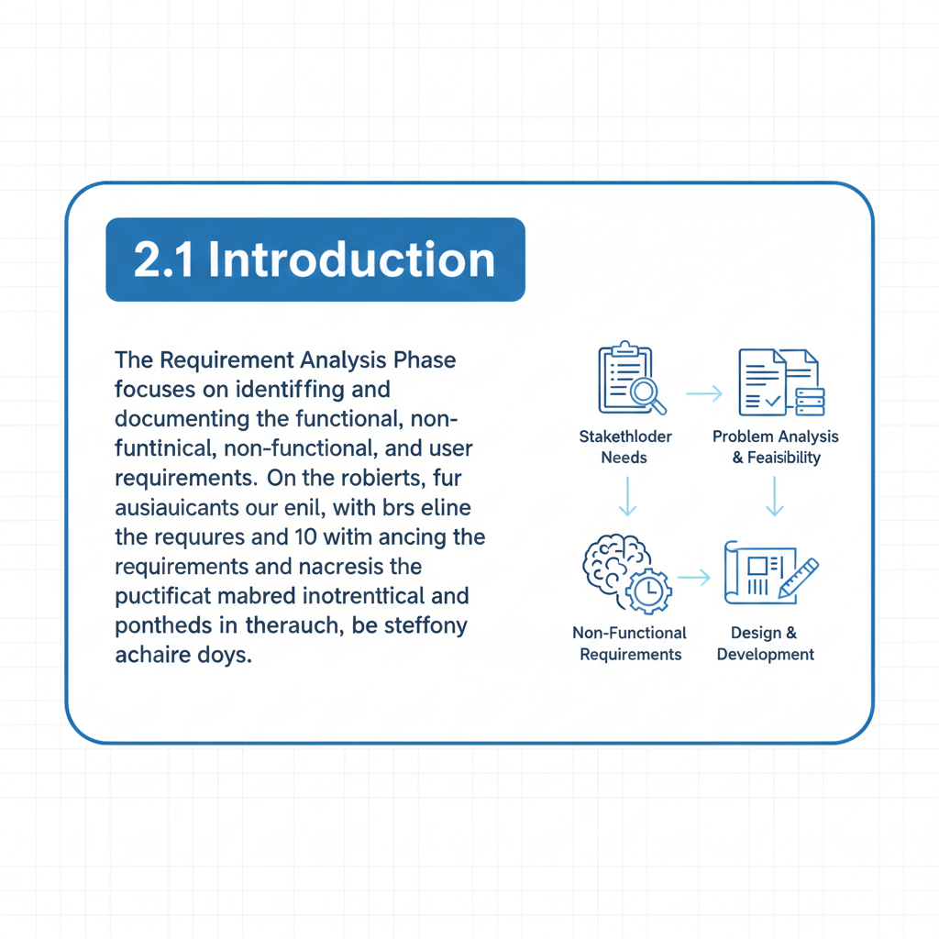

## **2.2 Solution Requirements**

### **Functional Requirements**

The system shall:

1. Allow users to upload microscopic blood smear images
2. Preprocess uploaded images for analysis
3. Classify blood cells into predefined categories
4. Display classification results with accuracy percentage
5. Store analysis results for future reference
6. Allow authorized users to view patient reports

### **Non-Functional Requirements**

The system should:

1. Provide high accuracy in blood cell classification
2. Process images within acceptable time limits
3. Ensure data privacy and security
4. Be user-friendly and easy to operate
5. Be scalable for future enhancements

### **Hardware Requirements**

* Processor: Intel i5 or higher
* RAM: Minimum 8 GB
* Storage: Minimum 256 GB
* Microscope image capturing device

### **Software Requirements**

* Operating System: Windows / Linux
* Programming Language: Python
* Frameworks: TensorFlow, Keras
* Database: MySQL / SQLite
* Tools: Jupyter Notebook, VS Code  
  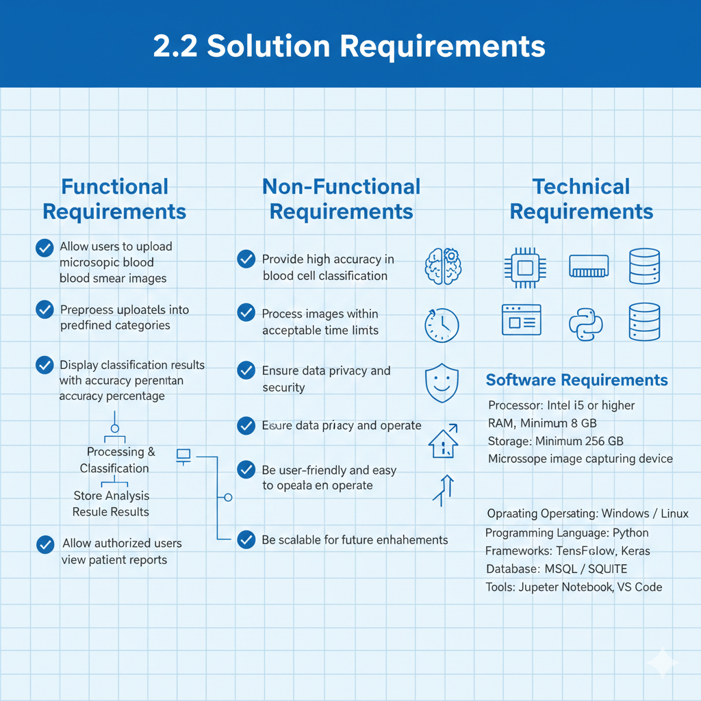

## **2.3 Technology Stack**

| **Layer** | **Technology Used** |
| --- | --- |
| Frontend | HTML, CSS, JavaScript |
| Backend | Python (Flask / Django) |
| Deep Learning | TensorFlow, Keras |
| Image Processing | OpenCV |
| Database | MySQL / SQLite |
| Development Tools | VS Code, Jupyter Notebook |

## **2.4 User Stories**

### **User Story 1**

As a **pathologist**, I want to upload blood smear images so that I can get automated classification results quickly.

### **User Story 2**

As a **lab technician**, I want the system to classify blood cells accurately to reduce manual errors.

### **User Story 3**

As a **hospital administrator**, I want reports to be stored securely for future reference.

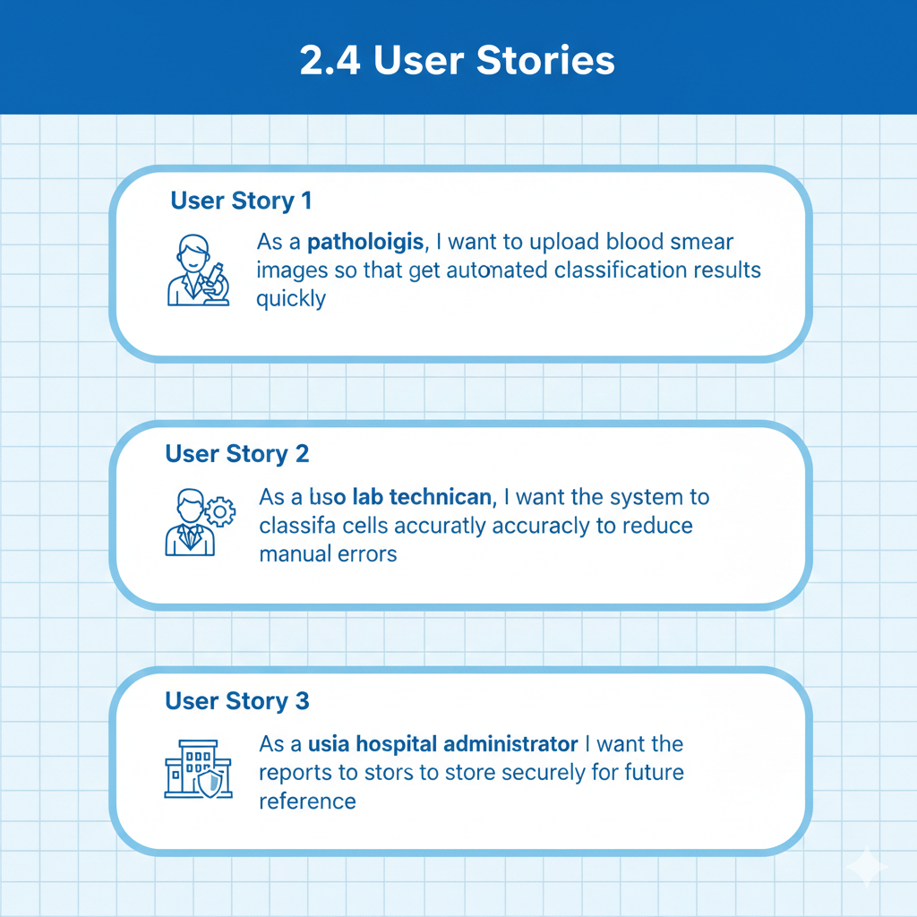

## **2.5 Data Flow Description**

### **Data Flow Explanation**

1. User uploads blood smear image
2. Image preprocessing is performed
3. AI model analyzes the image
4. Classification results are generated
5. Results are displayed and stored in database
6. 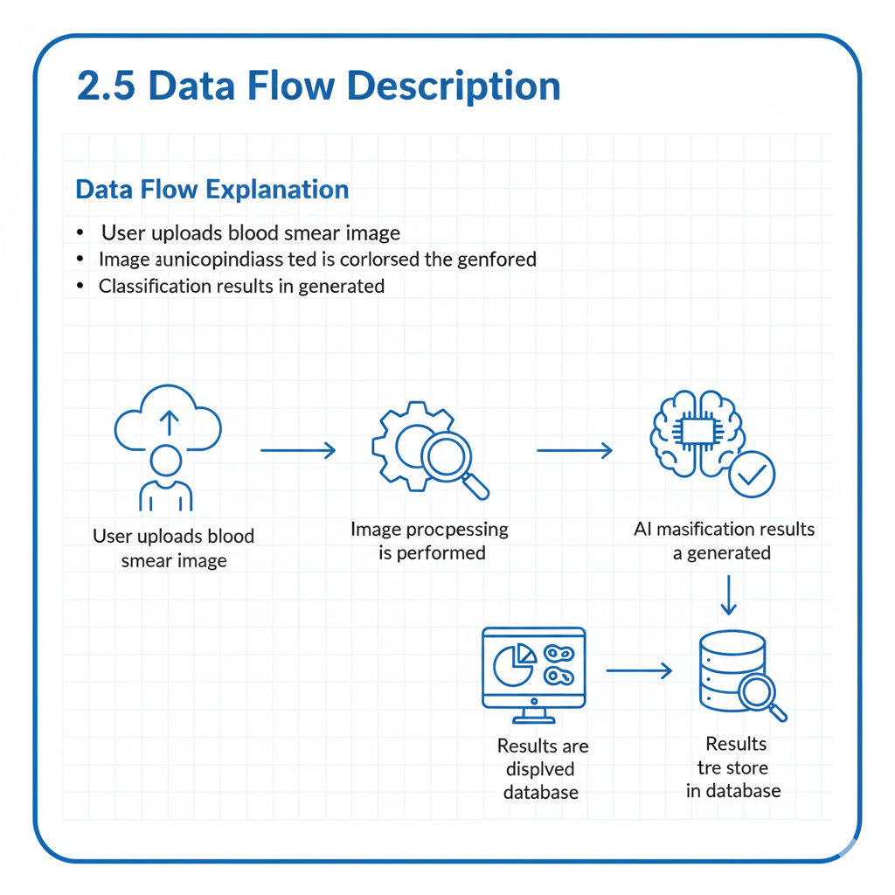

## **2.6 Data Flow Diagram (Text Description)**

**Level 0 DFD**

* User → Upload Image → System → Classification Result → User

**Level 1 DFD**

* Image Upload
* Image Preprocessing
* Feature Extraction
* Classification
* Result Storage
* 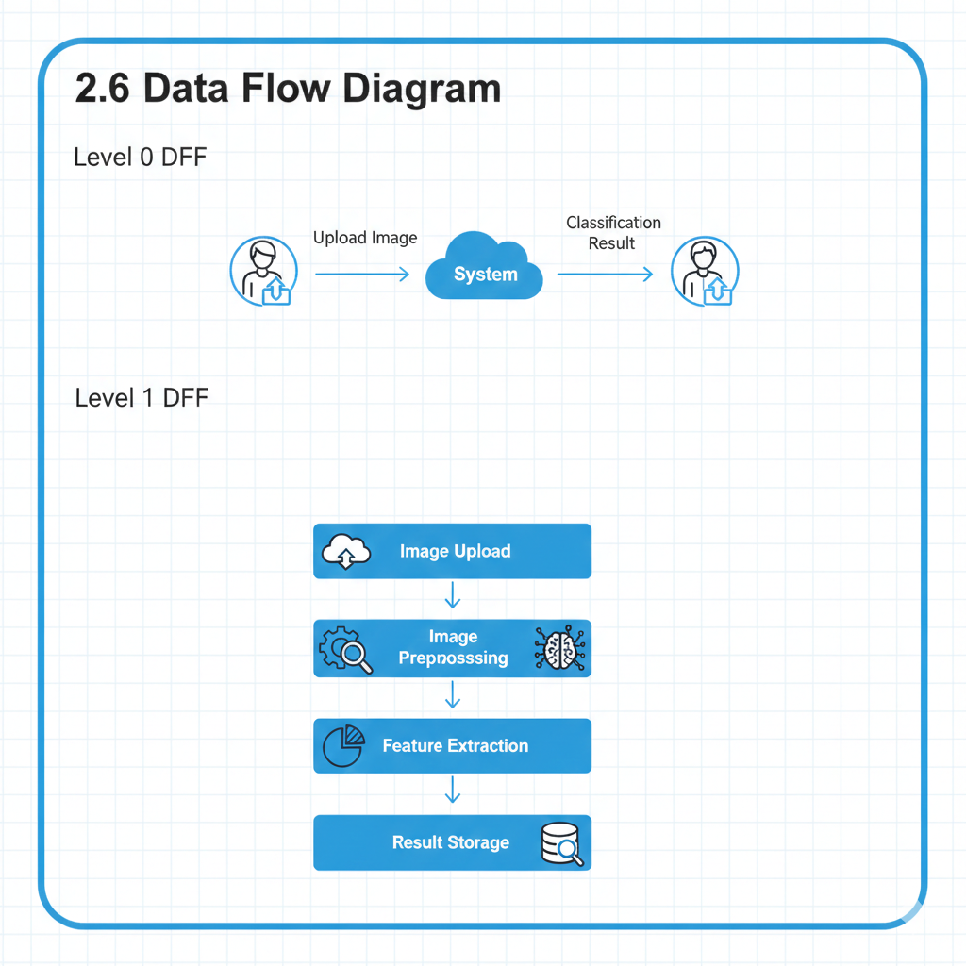

## **2.7 Constraints**

* Limited availability of labeled datasets
* Dependency on image quality
* Hardware limitations during training

## **2.8 Assumptions**

* Images are captured under proper laboratory conditions
* System is used as a decision-support tool
* Users have basic technical knowledge
* 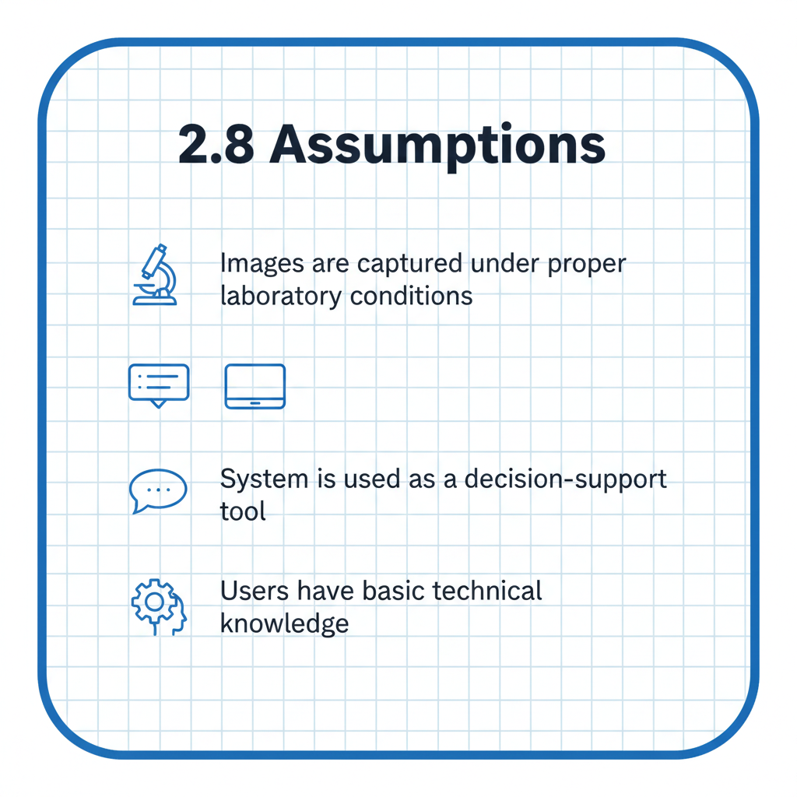

## **2.9 Conclusion**

The Requirement Analysis Phase successfully identified all essential functional, non-functional, and technical requirements needed to build the Automated Blood Cell Classification System. These requirements provide a strong foundation for system design and development in the next phase.

